13.Creating and managing index estooptimize database per for mancEe.

CREATE DATABASE test;
USE test;
CREATE TABLE employees(
id INT AUTO_INCREMENT PRIMARY KEY,
name VARCHAR(100),
email VARCHAR(100),
department VARCHAR(50),
hire_date DATE
);
INSERT INTO employees(name,email,department,hire_date)
VALUES
('Ashiwni','ashwini@example.com','IT','2020-01-15'),
('Puja','puja@example.com','HR','2021-03-10'),
('Sejal','sejal@example.com','IT','2019-07-22'),
('Neha','neha@example.com','Finance','2022-11-01');
SELECT*FROM employees;
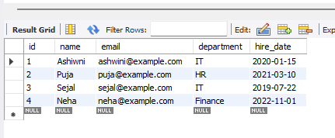
--Step4:-Create indexes
--Index on ‘name’
CREATE INDEX idx_emp_name ON employees(name);
--Unique index on ’email’
CREATE UNIQUE INDEX idx_emp_email ON employees(email);
--Composite index on ‘department’ and ‘hire_date’
CREATE INDEX idx_dept_date ON employees(department,hire_date);
--Step5:- view indexs
SHOW INDEX FROM employees;
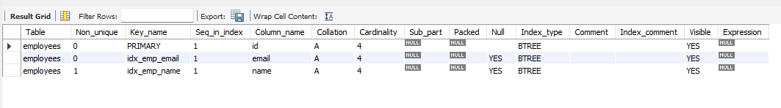
- Step 6:- USE EXPLAIN to see if index is used
EXPLAIN SELECT*FROM employees WHERE name ='ashwini';
